Technical Architecture:

Project Design Phase-II Technology Stack (Architecture & Stack)

|  |  |
| --- | --- |
| Date | 26. 10. 2022 |
| Team ID | B9-3A5E |
| Project Name | Project - Digital Naturalist - AI Enabled tool for  Biodiversity Researchers |
| Maximum Marks | 4 Marks |

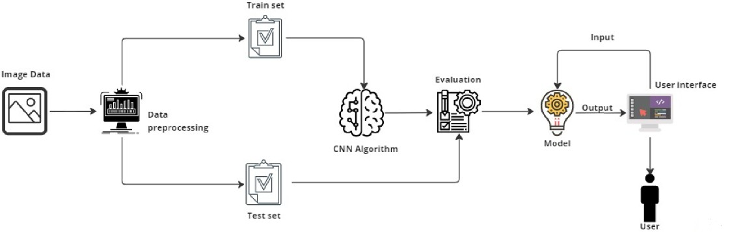

Table-1 : Components & Technologies:

|  |  |  |  |
| --- | --- | --- | --- |
| **S.No** | **Component** | **Description** | **Technology** |
| 1. | User Interface | Web UI or Website | HTML, CSS. |
| 2. | Application Logic-1 | Image upload | Python Flask. |
| 3. | Image Recognition Model | To predict the species(flora and fauna), through image provided by the user | CNN |
| 4. | Infrastructure (Server / Cloud) | Application Delpoyed on cloud server | IBM Cloud |

Table-2: Application Characteristics:

|  |  |  |  |
| --- | --- | --- | --- |
| **S.No** | **Characteristics** | **Description** | **Technology** |
| 1. | Open-Source Framework | Opensource frameworks for preprocessing, web application and model training | Keras, Python Flask, TensorFlow, CNN, sklearn and matplotlib |
| 2. | Data Preprocessing | The security / access controls are implemented  using firewalls etc. | Firewall and other security related  softwares. |
| 3. | Scalable Architecture | Justify the scalability of architecture (3 – tier, Micro-services) | Data , models, operate at size, speed , consistency and complexity |
| 4. | Availability | The availability of application (e.g. use of load  balancers, distributed servers etc.) | Image recognition. |
| 5. | Performance | Design aspects for the performance of the application (number of requests per second, use of Cache, use of CDN’s) etc. | Full and effective prediction using deep learning for Bio-Diversity researchers |